Chandler de Spirlet

ASEN 1969

23 April 2019

Prof. Chris Koehler

Community Service Reaction

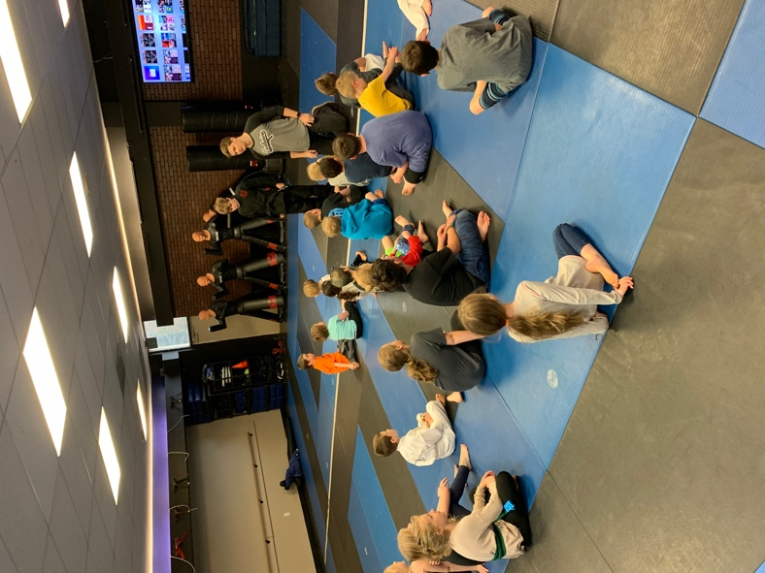 My community service was to spend the day with students at a martial arts school I formerly trained at. Throughout the day, I played games with the kids and kept them entertained. A portion of the day was spent teaching the kids different coding practices through a website called code.org. At first, I used my computer to AirPlay the exercise to the TV found in the background of the image. After we spent an hour working as a group to solve some of the problems the kids chose, I distributed the four iPads that the school owns and let kids take turns working on their own, or in pairs, while everyone else played other games. Before the event, I was a little nervous about teaching some basic programming concepts because I know that the syntax of programming languages can be confusing to people, especially kids who are between 6 and 12 years old. During the event, I felt that they were trying to grasp some of the concepts, and eventually picked up on how to use the proper problem-solving techniques. Many of the kids expressed interest in continuing after the day was over and mentioned that they were going to continue their exercises on code.org once they got home. It definitely felt great to share knowledge and spread some passion for coding among a younger generation. I would most certainly like to do something very similar, if not the same thing, again. I really enjoyed being able to work with kids who wanted to learn something and had an interest in something that I am very passionate about. This event was held at Exclusive Martial Arts on Thursday, 28 March 2019. I formerly trained at Exclusive Martial Arts and was contacted by one of the owners who asked if I wanted to spend the day with some of their students. For Spring Break, the school was hosting a series of Spring Break classes. I was the organizer for the event and handled the advertising within their school and the schedule for the day.